**Drones for Disaster Relief**

Brendan Hayes, Khader Syed, Christian Nyarko, Taylor Chamberlain

University of Maryland Global Campus SYSE 640-9040

August 10, 2021

Table of Contents

Background of Drones 2

Drone Systems – For Disaster Relief 4

Testing Processes & Methods 7

Verification & Validation 11

Challenges 14

Conclusion 17

References 18

### 

### 

### Background of Drones

An unmanned aerial vehicle (UAV), commonly known as a drone, is an aircraft without any human pilot, crew or passengers on board. Essentially, a drone is a flying robot that can be remotely controlled or fly autonomously through software-controlled flight plans in their embedded systems, working in conjunction with onboard sensors and GPS (Earls, 2019). The UAVs or drones’ history dates back to 1849 when Austrian soldiers attacked Venice with hot-air, hydrogen- or helium-filled balloons equipped with bombs (Earls, 2019). In the recent past, drones were mostly associated with military use, where they were used for anti-aircraft target practice, intelligence gathering and then, more controversially, as weapons platforms. With the maturing and miniaturization of applicable technologies in the 1980s and 1990s, U.S. Department of Defense (DoD) started the development of drones jointly with AAI and Malat (Earls, 2019). These were first put to use in the 1991 Gulf War. Since then the military use of drones has only increased world over. Drones manufacturing and use have been undertaken by many countries including Russia, Israel, Pakistan, China, Turkey, India and many more.

In recent times we have heard of Amazon actually making its first Prime Air package delivery in Cambridge, England in 2016, followed by a Prime Air drone delivery in California in 2017 (Earls, 2019). This has prompted other players like companies to plan for delivering anything from food to life-saving medical supplies in the case of an outbreak of any disaster or pandemics like Covid-19 that we have been witnessing for the last 18 months. The development of smart technologies and improved electrical power systems have led to the use of drones for consumer and general aviation activities. Drones in the present day are now used in a wide range of civilian roles ranging from search and rescue, surveillance, traffic monitoring, weather monitoring and firefighting, to personal drones and business drone-based photography, as well as videography, agriculture and even delivery services. This paper outlines the use of drones for the purpose of civilian use like disaster relief. The following sections describe the details of the system that is chosen for study and the system integration process that will be undertaken along with the verification, validation, and testing (VV&T) methodologies.

### Drone Systems – For Disaster Relief

Drones or unmanned aerial vehicles, as its name suggests it is a flying robot without human beings in the pilot seat. The unmanned or autonomous operation is what is driving the adoption of drones for civilian and non-military applications. Drones are increasingly used in non-military purposes such as delivering medical-supplies, scoping natural disasters, and search and rescue operations post any man-made or natural disaster. Examples of this could be man-made building collapsing, or bridge collapsing due to faulty engineering. Also, natural disasters like floods, hurricanes/cyclones, earthquakes, pandemic, mud-slides, or loss of energy to specified geographical location, etc. The unmanned characteristics provides leverage for utilizing drones in disaster relief when regular transportation lines of delivery are disabled or unable to reach the location due to extreme danger of personnel.

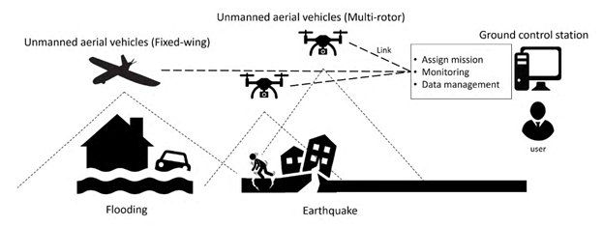

**Figure 1: Disaster relief operation using drones (Aljehani & Inoue, 2016)**

Drones can be deployed at the quickest possible time to assess the sites and plan the rescue and relief operation. “Drone images are particularly valuable for giving the public a sense of the size and scale of a given disaster, such as aerial photographs of a vast flooded area, or videos depicting the enormous size of a camp for people displaced by disaster” (Drones for Disaster Response and Relief Operations, 2015). In addition to assessing the situation, delivering materials to the site, the opportunity to expedite the search and rescue operation is proving to be the time that is crucial to save lives and avert any possible further dangers.

Drone Operations

A fleet of drones (SoS) are employed first to get a firsthand report of the situation by aerial images taken from the different cameras: thermal and infrared to help build a picture of an emergency situation, during or after the event (Oliver, 2020). From the live pictures and video streams a true scale of impact and damage can be assessed by the first responders and disaster rescue teams. These aerial images are used in conjunction with the existing maps to build a picture of the area, streets, buildings, roads, bridges, hospitals, schools, etc. Due to their speed and agility, drones are crucial in emergency situations and natural disasters of all kinds. Time is of the essence for any natural or man-made disaster. Drones make the difference in life or death by providing the quickest situational awareness to the responders at hand. With the aid of area images taken from cameras on drones, rescue teams on ground assess the best possible routes to transport rescue teams and send relief material by traditional transportation. Drones assess the damage, plan the rescue (if needed) and send in the relief delivery of supplies. Collecting data on the area's terrain, the response team can decide on the type of transportation that can be deployed without having to worry about facing dangerous obstacles within the route.

The drones with delivery payload capabilities themselves provide the ability to deliver the food, water and life-saving medical supplies when traditional transportation is not possible. Drones are also deployed to provide the temporary communication channels to aid the rescuers and people in distress to communicate before they are given relief and/or evacuated from the danger zone. “Drones generally offer a low-cost and easy to use means of collecting high-quality geospatial data after disaster” (Drones for Disaster Response and Relief Operations, 2015). For the scale and nature of the mission, i.e. disaster relief, one single drone might not be sufficient. The system of systems (SoS) drones provide capabilities for: incident reporting, situational awareness, mapping area terrain, payload for carrying disaster relief, and collecting geospatial data.

For routine operations, the drones need two basic functions: flight and navigation. For achieving the flight functionality drones will use a power source, such as battery or fuel, rotors, propellers and a frame. The construction of the drone frame is kept lightweight using composite materials which increases maneuverability during flight. Ancillary aids and devices that need to be integrated with the basic drones system for performing disaster rescue and relief operation: thermal imagers, infrared cameras, night vision cameras, live mapping, live video streaming, and relief delivery payload. For the flight control, it has a controller, which is used remotely by an operator to launch, navigate and land. Controllers communicate with the drones using radios and Wi-Fi. It has a GPS, accelerometer and altimeter in addition to the other aids meant for incident reporting like cameras and payloads to deliver material(s).

The disaster relief operation with drones is controlled from a centralized ‘control center’ with a backup site away from the main site. The control center will look after all the operations of drones from launching, flight, maneuvering and landing. To keep the drone operations and relief operations separate, the control center will concentrate on just operation of the drones, collection of incident data and delivery of relief material. The disaster operation center will concentrate on assessing the damage, lurking dangers (if any), situational awareness with the aid of data provided by the drone control systems. They then use the data including area terrain and maps to plan the rescue and relief operations.

### Testing Processes & Methods

Drones for disaster relief have been demonstrated to provide lifesaving aid to victims of a disaster such as hurricane or system -wide failure of electrical or communications infrastructure (Arcargonews, 2019). Testing of drones is crucial because of the cargo that is onboard the aircraft: blood samples, food/water and medical products that might be essential to save lives. Another essential part of testing drones lies in their aerial capabilities. Disaster drones must be able to assess the damages through constant observations and report back data with proper communication of corporations (ie: Red Cross, or Hurricane Relief, etc.). The main testing process that is utilized for disaster relief drones will be demonstration through modeling and simulation (M&S). M&S is cheaper, safer, controlled, and repeatable compared to live tests. Drones have to be successfully tested through simulated scenarios to demonstrate their capabilities before being utilized in emergency situations.

The Texas A&M Engineering disaster training facility includes life-size structures including overturned trains, rubble piles, in order to simulate a variety of disaster types with degrees of destruction (Drones for Disaster Response and Relief Operations, 2015). With testing drones, it is important to utilize simulation in an operationally realistic environment. Instead of testing the drones in a live disaster such as hurricane, flooding or bombing, the test facility will simulate the disaster scenarios and then utilize the demonstration methodology. The drone will be operating in the simulated disaster environment to demonstrate that it is capable of functioning in this specified situation. “A demonstration of the system can be functionally equivalent to testing it,” (Litant, 2021). Performance will be monitored for the system under test (SUT) to ensure any risk or malfunctions can be mitigated before the drone is used for its intended purpose.

Evaluation of Alternative Testing Methodologies

As previously mentioned, drones for disaster relief have been utilized since 1991 in the Gulf war. Previous carriers were tested successfully in combat, and therefore the SOT has been verified through certification. However, with updates to drone software, hardware, design, materials and manufacturing techniques it is still essential to test the specified SOT for disaster relief. Alternative testing methodologies could include digital simulation, since an actual disaster cannot and should not be recreated for testing purposes. Figure 2 depicts the digital simulation versus the “live” simulation outlined in the previous section.

### 

**Figure 2: Real vs. Digital Testing of Drones (Velasco, Valente, Alhama Blanco, & Abderrahim, 2020)**

The data collection, terrain mapping, communication and delivery technologies will advance along with the need for more safety and operational regulations. All these will add to the VV&T efforts. We can look forward to independent external VV&T resources who could offer the testing and certification services to elevate some of the burden of system testing. The organizations can then focus on core VV&T components of disaster relief and outsource the testing of drone technologies to outside organizations who specialize in testing and qualification of the same.

Testing Facilities

Integration of drones (UAS) for disaster relief or Search and Rescue (SAR) into the National Airspace (NAS) is still a challenging issue due to regulation and legislation, privacy and safety requirements, public perception, and presence. The issue is “exacerbated by the complexity of the NAS and the dramatic increase in traffic density” (SAR_UAS. Pg. 27) which further adds to the operational limitation of recovery drones. Some environmental requirements instituted by test sites include distance to flight-build up, general presence of people, maximum height restrictions, line of sight — VLOS (visual line of sight), EVLOS (extended visual line of sight), and BVLOS (beyond visual line of sight) and administrative procedures such as flight permissions, pilot licensing, and data collection authorization. To integrate UAS into the NAS, the *FAA Modernization and Reform Act* must establish test sites for UAS and expedite public-uses waiver process. There are currently 7 test sites established in the US for development and testing UAS (drones); Griffiss International Airport, NY, New Mexico State University, NM, North Dakota Department of Commerce, ND, State of Nevada, NV, Texas A&M University Corpus Christi, TX, University of Alaska Fairbanks, AK, Virginia Polytechnic Institute & State University, VA. Any other testing environment must be coordinated through the designated FAA sites listed above.

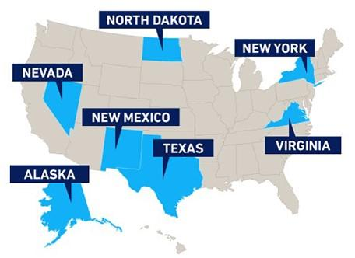

**Figure 3: Illustrates a map of the 7 FAA UAS test sites for drones**

FAA approved testing environments for drones to include disaster recovery UAS have been listed above. The FAA mandates drone operators to be certified to be able to perform physical testing and flying drones to reduce the risk of non-compliance and product liability issues (safety to people and property). For disaster recovery drones, additional environmental testing is necessary to replicate events that require the functional performance of drone applications. Due to the dynamic nature of the environment and the complexities that arise from natural disasters, modeling and simulation can be used for testing environments given that enough data from past disasters are available to simulate disasters or events which require drone application for recovery missions. Even with enough data to simulate natural disasters to help with drone testing capabilities to help with disaster relief, it is quite difficult to replicate comparable disasters due to unpredictability of events. It is quite difficult and challenging to create a testing environment that mirrors actual events in a natural disaster. Physical testing of power consumption, operation distance, communication (latency issues), etc. can be coupled with environmental modeling/simulating of disasters to increase safety standards and low tolerance risk of drone operation.

Privacy Requirements

FAA is not the authority for regulating privacy therefore it does not have the authority to impose privacy requirements on test environments. Other government statutory bodies regulate privacy of test sites. UAS such as drones should comply with existing state, city and county safety frameworks as defined in the limit of the law.

### Verification & Validation

Verification is the, “confirmation, through the provision of objective evidence, that specified requirements have been fulfilled,” and, “the evaluation of whether or not a product, service, or system complies with a regulation, requirement, specification, or imposed condition. It is often an internal process,” (ISO/IEC/IEEE, 2017, p. 503). Validation is the, “confirmation, through the provision of objective evidence, that the requirements for a specific intended use or application have been fulfilled,” (ISO/IEC/IEEE, 2017, p. 499). It is important to note that while verification and validation (V&V) might typically be an internal process, the V&V for the disaster relief system of UAS’ has to be completed in coordination with the FAA in order to get accredited to fly in the NAS. Figure 2 depicts an FAA endorsed approach to V&V.

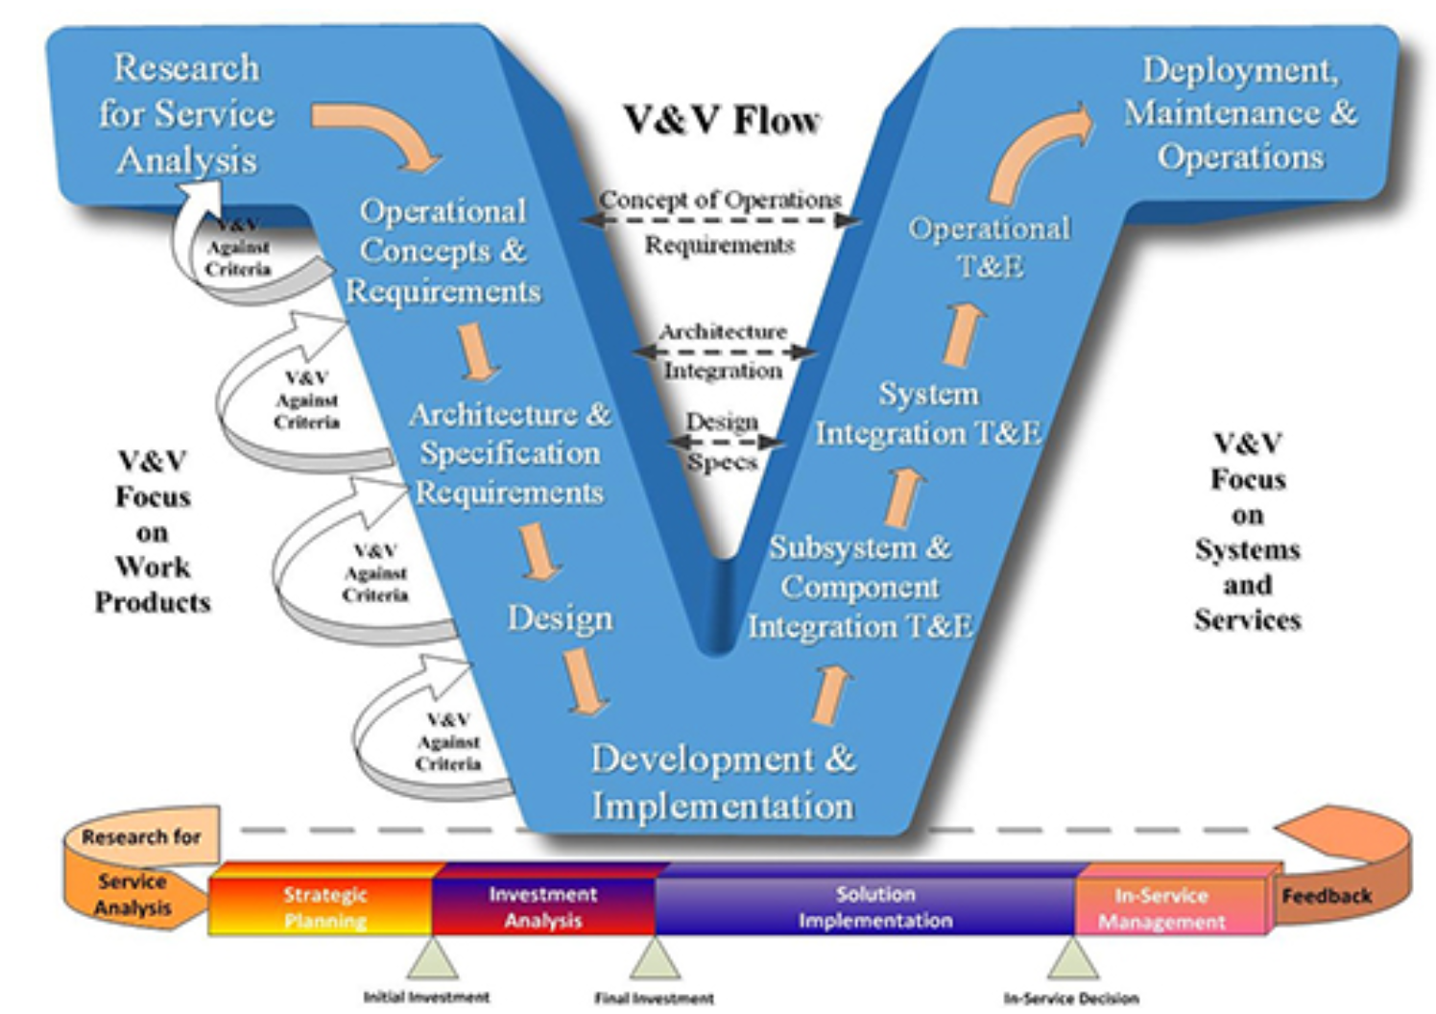

**Figure 4: V&V Flow (FAA, 2020)**

Following this Vee model approach to systems engineering and design places an emphasis on the V&V of the UAS system. Continuously revisiting the requirements for V&V throughout design and iteratively feeding that information into design criteria ensures that test requirements are comprehensive prior to entering development and operational test and evaluation (DOT&E).

Traditional V&V processes for aircraft take advantage of common industry standards and historic data that has been accumulated through countless hours of test flights. Modeling and simulation (M&S) can play a key role in this as well, utilizing countless test flights and thousands of hours of data collected over decades of manned flight to improve fidelity and increase the accuracy of M&S. UAS flight and the interaction between manned and unmanned aircraft in NAS is rare and so the fidelity of the M&S is not to the level of manned aircraft. “V&V methodologies and techniques are typically underpinned by inviolate scientific principles…Thus, V&V processes currently employed in aviation (and most other physical applications) are geared toward obtaining quantitatively predictable outcomes based on known inputs of stimuli… However, even a statistical evaluation of system behavior may not be adequate for V&V of autonomous systems,” (National Research Council [NRC], 2014, p. 38). When a system, by design, is meant to be adaptive in its responses to environmental stimuli, it can be difficult to create repeatable results in tests. The focus of V&V for autonomous UAS systems needs to shift to ensure appropriate decisions are made by autonomous systems despite not making the same decision during each test. Machine learning coupled with the adaptive decision making of autonomous systems is a critical enabler of future technologies and requires V&V processes that are aligned (NRC, 2014).

System integration testing plays a critical role in the V&V of disaster relief and recovery drones due to the breadth of roles they might play. Payloads for the disaster drones could include an array of different sensors, cameras, systems for delivering/recovering loads, communications systems, etc. These payloads must seamlessly integrate with the hardware and software utilized by the air vehicle of choice. Additionally, the systems onboard the air vehicle must integrate with external systems like ground control stations. Autonomous systems will still be required to communicate with command centers to share data and receive direction. While hardware and software elements of the system will have their own V&V processes, system integration will bring those elements together and ensure that they align with the system’s architecture and result in a system or partial system that complies with the specified requirements (IEEE, 2012).

Certification of aircraft, including UAS, is critical upon the path to flight within the NAS. Figure 5 illustrates the FAA’s paths towards flight for UAS’ in the United States.

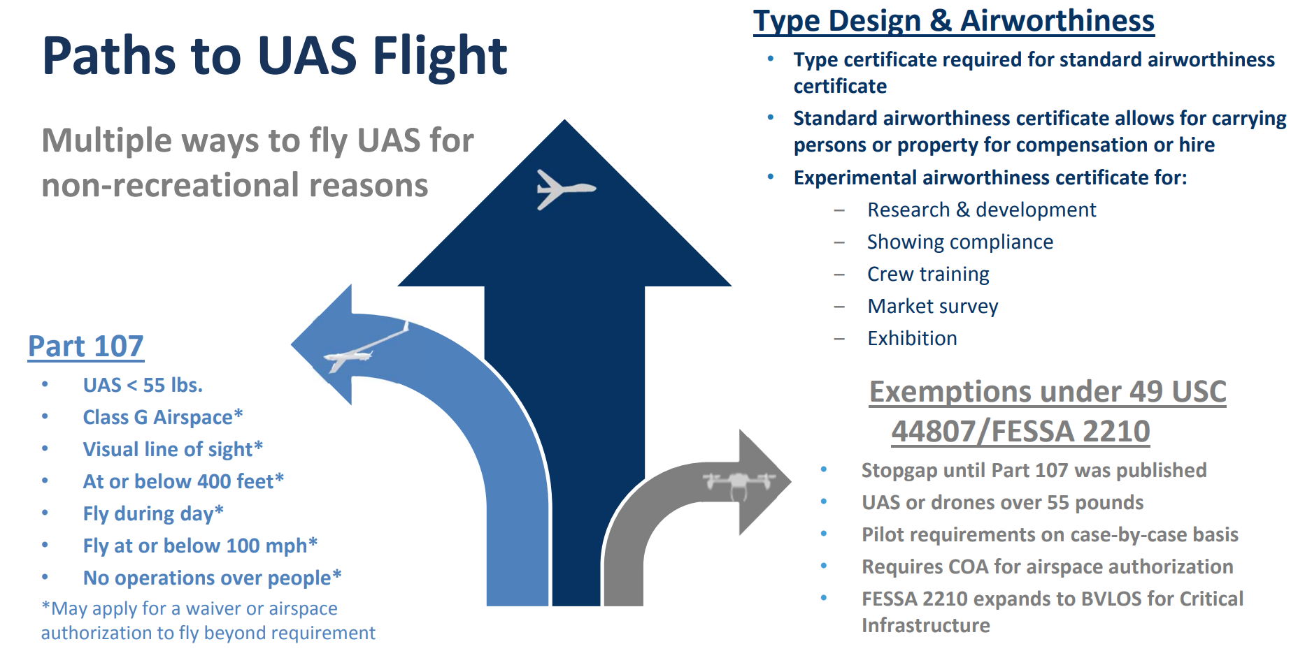

**Figure 5: Path to UAS Flight (FAA, 2020)**

According to the FAA (2020), there are two major types of certifications that a large-scale UAS system for disaster recovery and aid would be required to have prior to mass production and employment. “Type certification is the approval of the design of the aircraft and all component parts (including propellers, engines, control stations, etc.). It signifies the design is in compliance with applicable airworthiness, noise, fuel venting, and exhaust emissions standards,” (FAA, 2020, para. 3). Production operations must also be certified so that quality assurance and standardization of production processes ensures no great variance to configurations within the type certification. Critical to flight is an airworthiness certification which allows the operation of civil aircraft in the NAS without special exemptions being required, as well as confirming the capability for safe operation of said aircraft (FAA, 2020). While disaster relief systems might be able to obtain FAA exemptions for flight in areas of disaster, often these disasters can be unpredictable and time is scarce when executing emergency operations, making a full FAA certification a necessity. Although certification through the FAA can be cumbersome, it is a necessary process.

### Challenges

Drones have been successfully used in military applications due to developed communication networks between UAS and Ground Control Stations (UGS). However, commercialization of drones for large-scale adoption for disaster recovery use cases presents challenging issues due to under-developed architecture of multi-UAS systems with unregulated network and control station solutions to assist information flow between UAS operations and UGS. The issue of communication can be solved by developing secured network architectures to handle the multi-UAS application systems and its resource platforms. Commercialization of drones for disaster relief and other applications will increase drones use cases and as such its complexity leading to congestion. Therefore, exploring other areas of system of systems (SoS) like IoT and other machine learning applications can help with path planning while optimizing communication efforts between the multi-UAS environment to ensure safer operations. Also, the issue of traffic congestion must be addressed with airspace design solely for drones (disaster recovery).

Funding and resource constraints – Pre-disaster testing of drones use cases for disaster relief will depend on reliable and safe drone technology “beyond the prototype stage to enable large scale deployment” (Vota, 2018) for relief missions. Drone technology is still in its nascent stage with a very limited and tightly regulated infrastructure for development. Unavailability of matured infrastructure for drone development and testing has made the device very expensive. Stakeholders are reluctant to invest in drone technology research due to the cost and regulations/limitations surrounding its use. Also, lack of regulatory guidelines and policy has made large scale adoption of drone technology very difficult which in tends affects development and testing of this novel technology for use cases of disaster relief efforts.

Overcoming payload capacity, battery life and distance (Beyond Visual Line of Sight) – the FAA restrictions on payload of drones and its contents currently sits at 55 lbs. which may not be enough during disaster response events. To satisfy the weight requirement, drones would have to make multiple trips in delivering payload to emergency areas which ultimately affects its battery life. Also, the FAA is very restrictive when it comes to operators maintaining a direct line of sight during drone operations. To circumvent these restrictions, operators must provide risk mitigation guidelines for FAA approval before they can be allowed to fly beyond visual line of sight. The line-of-sight, altitude limitations coupled with other restrictions and public perception of drones has led to testing and development of drones abroad.

Liability and Public Distrust – most drones fly at a much lower altitude than planes and helicopters. The proximity (100 – 600 feet, Class G airspace) of UAS to humans presents acceptance issues when privacy is taken into consideration (Pozner, 2020). This is because most drones are equipped with GPS, cameras and other sensing devices needed for location assistance to deliver payload and perform other mission essential tasks. Despite easing restrictions on pilots licensing for UAS operations, drone operators are still subjected to daylight flying operations and non-populated areas due to privacy concerns even after obtaining Certificate of Waiver or Authorization (COA) and passing the FAA safety recommendations. Moreover, easing pilot licensing restrictions increases public mistrust about drone technology with the concern that everyone can now operate a drone without the necessary training if they can get their hands on a COA. This raises safety concerns that must be overcome before public acceptance of the technology. Another significant use case of drones that has led to public mistrust of the technology is its use in military application. Bresnahan (2016) affirms this misconception when she reiterates Amukele view of the drone reputation by saying “when we say the word drones, people think of things that fly over their heads and kill their children”. Commercialization and disaster recovery drones will attract more stakeholders/investors to encourage development of the technology if the public perception of the technology is positive rather than negative. Safety concerns must be addressed. One way to achieve a positive public perception of the technology is to ensure safety guidelines and security of drone application.

### Conclusion

Advancements in technology will only further allow UAVs to mitigate the devastation caused by natural disasters, as well as becoming an ever more valuable utility available to emergency responders all over the world. “Drones permit disaster responders to quickly create usable, actionable maps, and to rapidly impact a disaster’s effects on the community,” (American Red Cross, n.d.). Disaster recovery in one incident will help plan for how to mitigate the effects if a similar event were to happen in the future. In the wake of earthquakes, flood or fire, drones can assist in the safe inspection of infrastructure so that repairs can be made more quickly than if they were done using traditional methods. With the potential of revolutionizing disaster planning, it is also important that policies are implemented by lawmakers to ensure the safe integration of drones into the NAS system (Drones for Disaster Response and Relief Operations, 2015). Drones can not only deliver supplies needed for disaster relief but also provide crucial situational awareness to the humanitarians responding.

### References

Aljehani, M. & Inoue, M. (2016) IEEE Access: *Performance Evaluation of Multi-UAV System in Post-Disaster Application.* Retrieved from https://ieeexplore.ieee.org/stamp/stamp.jsp?tp=&arnumber=8715365

Benefits and costs of drone use for disaster response. (n.d.). Retrieved August 07, 2021, from https://americanredcross.github.io/rcrc-drones/benefits-costs.html

Bresnahan, S. (2016). The Good Drones: Air Delivery of Blood Samples Could Save Lives. *CNN Health.* Retrieved https://www.cnn.com/2016/02/19/health/drones-deliver-healthcare-samples/index.html

Drone test to deliver humanitarian aid. (2019, April 17). Retrieved August 07, 2021, from https://www.aircargonews.net/airlines/freighter-operator/drone-test-to-deliver-humanitarian-aid/

Earls, Alan. (July, 2019). *IoT Agenda - Drone (UAV)*. Retrieved from https://internetofthingsagenda.techtarget.com/definition/drone

FAA. (2020). Certification. Retrieved from https://www.faa.gov/uas/advanced_operations/certification/

FAA. (2021). UAS Test Site Locations. Retrieved https://www.faa.gov/uas/programs_partnerships/test_sites/locations/

FAA. (2013). Unmanned Aircraft System Test Site Program. Retrieved https://www.federalregister.gov/documents/2013/11/14/2013-27216/unmanned-aircraft-system-test-site-program

ISO/IEC/IEEE. (2017). *International Standard ISO/IEC/IEEE 24765: Systems and software engineering — Vocabulary*. Geneva and New York: International Organization for Standardization, the International Electrotechnical Commission and the Institute of Electrical and Electronics Engineers. doi:10.1109/IEEESTD.2017.8016712

IEEE. (2012). *International Standard IEEE 1012: Standard for System and Software Verification and Validation.* New York: Institute of Electrical and Electronics Engineers. doi: 10.1109/IEEESTD.2012.6204026

National Research Council. (2014). *Autonomy Research for Civil Aviation: Toward a New Era of Flight*. Washington, D.C.: The National Academies Press. doi: 10.17226.18815

Oliver, Francesca. (2020, Oct 20). SOARIZON: *Six ways drones are helping in emergency response.* Retrieved from https://www.soarizon.io/news/six-ways-drones-are-helping-in-emergency-response

SAR_UAS_Addendum. (2016). Unmanned Aircraft System (UAS) Search and Rescue. Retrievedhttps://connect.ncdot.gov/resources/Aviation%20Resources%20Documents/SAR_UAS_Addendum(July2016_Vers_1-0)-Final.pdf

Sharma, A., Vanjani, P., Paliwal, N., Basnayaka, C., Jayakody, D., & Wang, H. (2020). Communication and Networking Technologies for UAVs: A Survey. *ScienceDirect.* Retrieved https://www-sciencedirect-com.ezproxy.umgc.edu/science/article/pii/S1084804520302137?via%3Dihub

Velasco, O., Valente, J., Alhama Blanco, P. J., & Abderrahim, M. (2020). An open simulation strategy for rapid control design in aerial and maritime drone teams: A comprehensive tutorial. *Drones,* *4*(3), 37. doi:10.3390/drones4030037

Vota, W. (2018). 5 Challenges to Scalling Unmanned Aerial Vehicles in Global Health. Retrieved https://www.ictworks.org/challenges-unmanned-aerial-vehicles-global-health/#.YP2fPuhKiUk